- Install PHPMyAdmin

sudo apt install phpmyadmin php-json php-curl

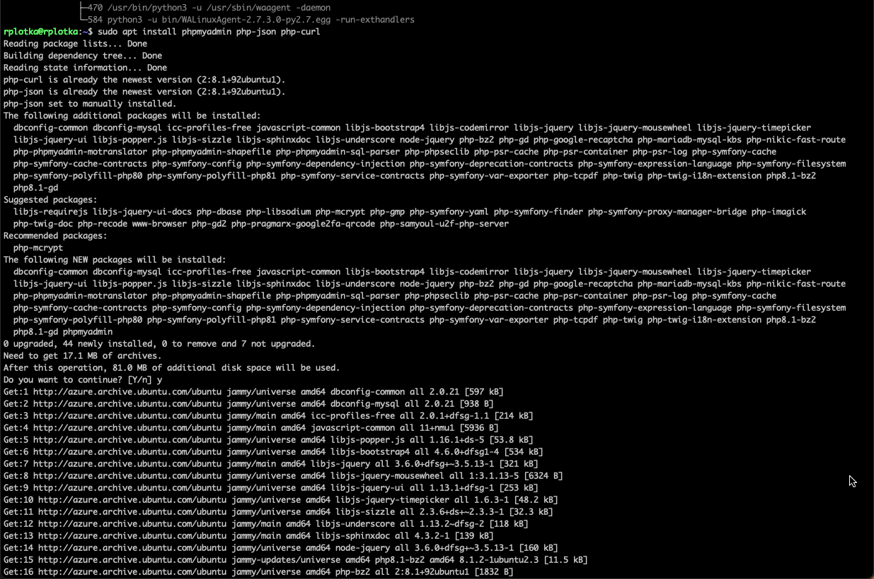

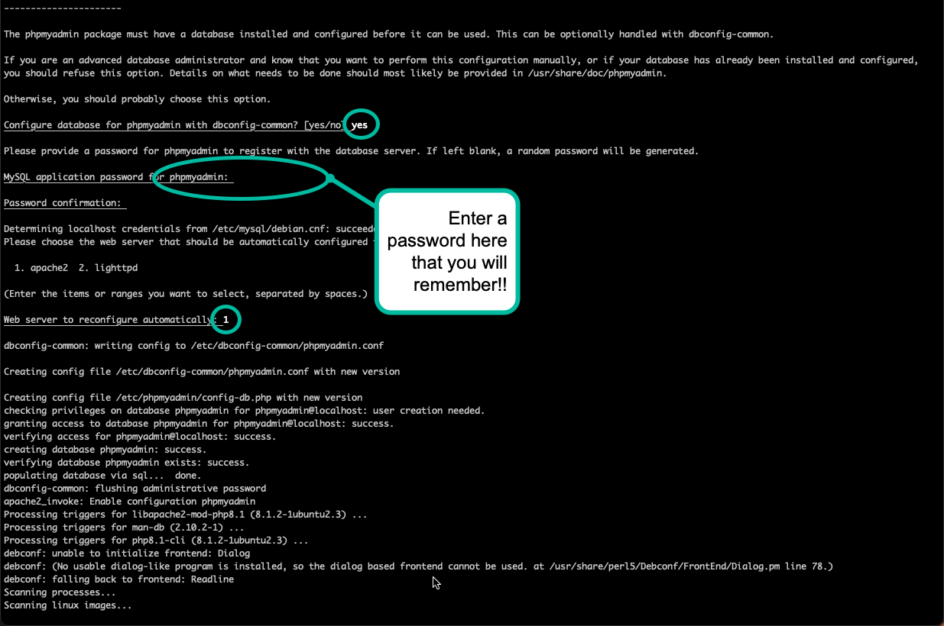

OK – now that that is done, let’s make it accessible from out iit websites…

Create a link so that we can easily access PHPMyAdmin from the server without using a virtual host (More on this in the future)

Sudo ln -s /usr/share/phpmyadmin /var/www/html/iit/.

Let’s check it out

First the folder:
ls -la /var/www/html/iit

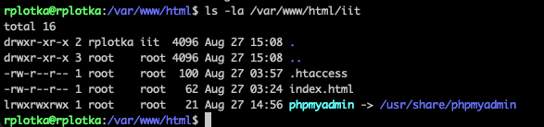
Notice that our files so far.
- .htaccess file (for security)
- Index.html (file that shows – Hello World!)
- Our link to PHPMyAdmin

Now in the browser:
http://[yourFQDN]/iit/phpmyadmin/

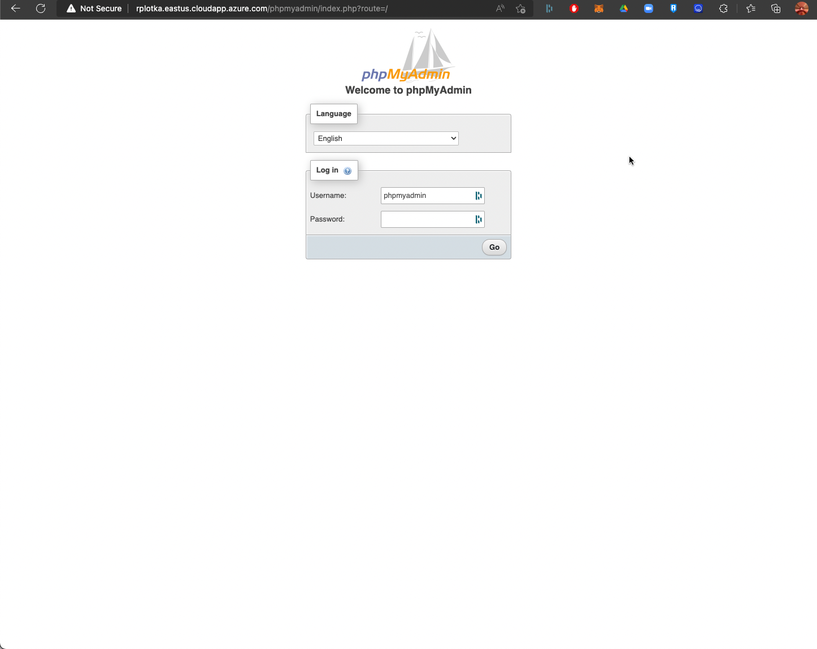

Login with phpMyAdmin user ID and the password you entered above

Print out this page
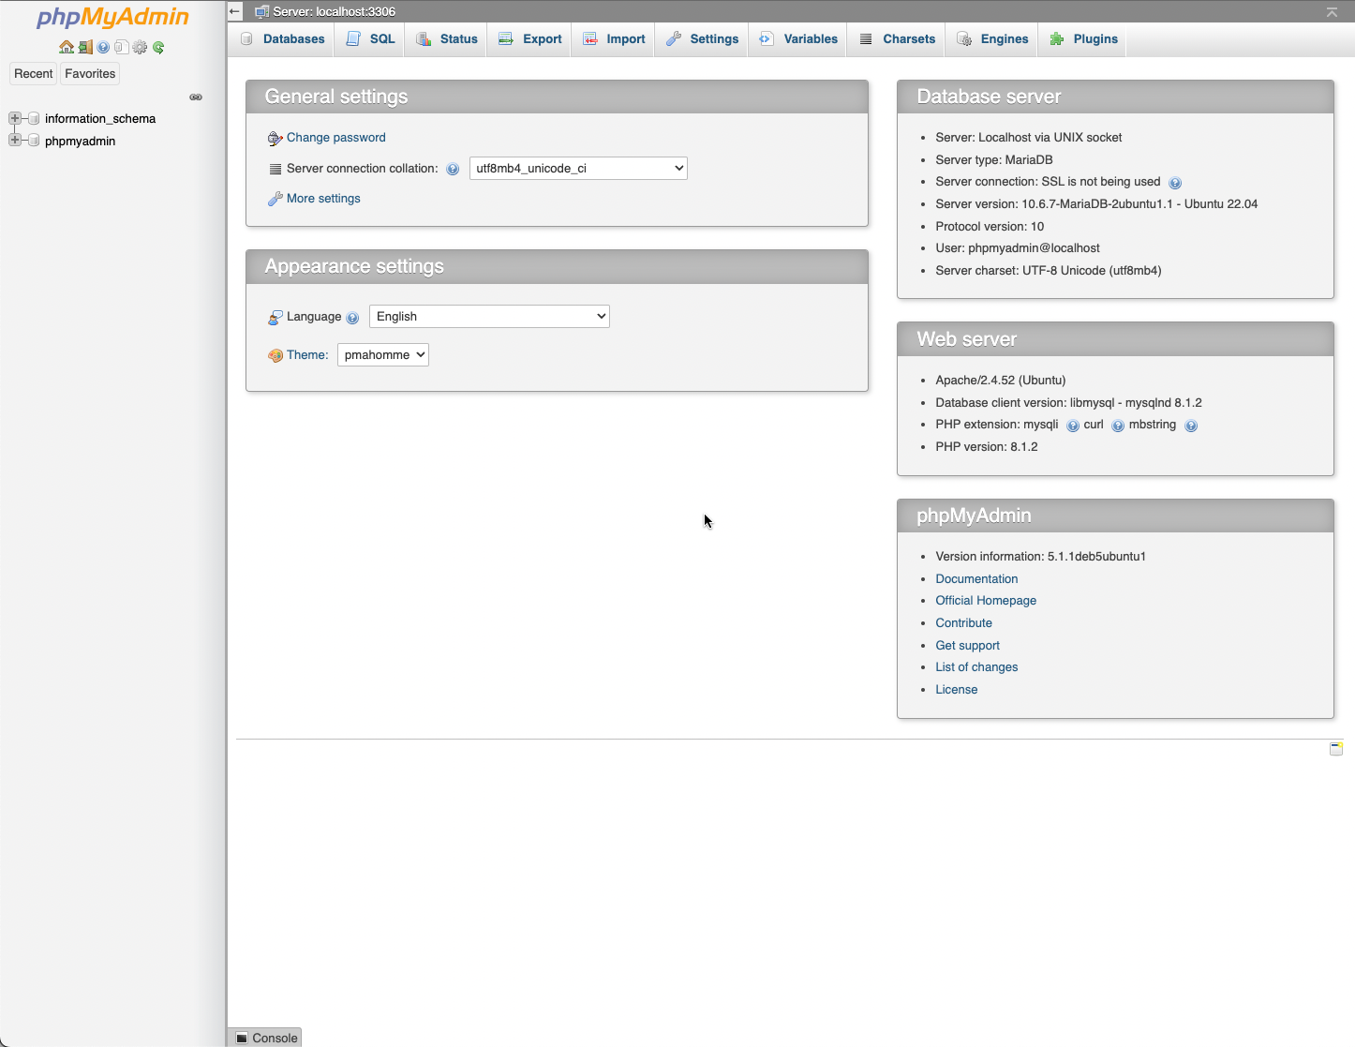

Test this also from a Private Browser. It should prompt for the same userid and password as when trying to go to your /iit website

We now have installed PHPMyAdmin to our sites to allow us to manage our database servers! More on this in the future as well.

